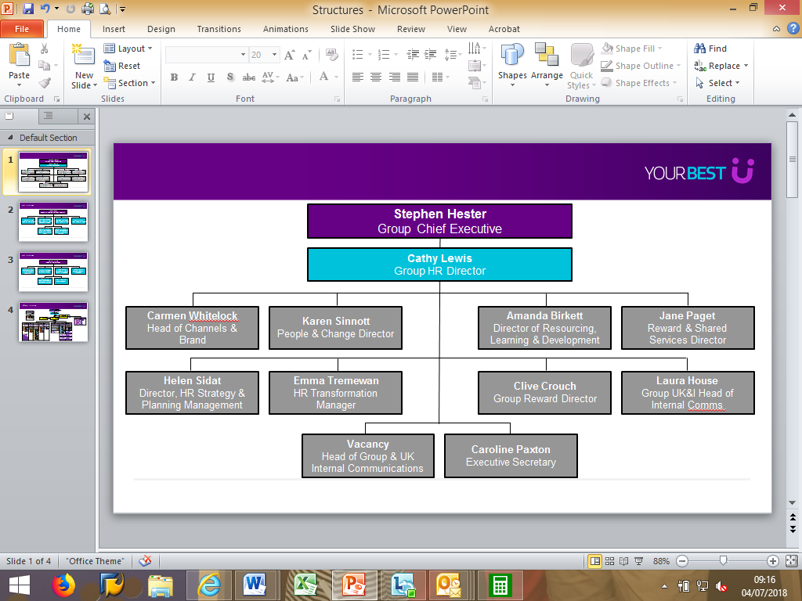

ROLE PROFILE

|  |  |  |  |
| --- | --- | --- | --- |
| **Role Title :** | Software Engineer (.Net) | **Reference no (where relevant)** |  |
| **ET/ Functional Area e.g. CRS/Finance :** | CIO | **RSA Level – Reward Team to confirm:** | L5P |
| **Reports to (role title) :** | Lead Software Engineer | **RSA Level reported to :** | L4P |
| **Head of People :** |  | **Date:** | 25 / 03 / 2024 |

|  |
| --- |
| **ROLE PURPOSE** |
| The Software Engineer is a proficient and experienced professional within the engineering team. In this role, the Software Engineer is responsible for designing, developing, and maintaining software applications or systems. They possess a deep understanding of programming languages, software development frameworks, and best practices. The Software Engineer collaborates with cross-functional teams to gather requirements, translate them into technical specifications, and develop high-quality software solutions. They are involved in the entire software development life cycle, including coding, testing, debugging, and deployment. The Software Engineer actively participates in code reviews, provides technical guidance and support to junior team members, and ensures adherence to coding standards and project timelines. This role requires strong problem-solving skills, excellent programming abilities, and a commitment to delivering robust and scalable software solutions. |

|  |
| --- |
| **KEY ACCOUNTABILITIES** |
| * Design and develop software applications: Design and develop software applications or systems based on project requirements. Translate functional specifications into technical designs and implement them using appropriate programming languages and frameworks. * Collaborate with cross-functional teams: Work closely with stakeholders, product managers, and designers to understand business requirements and user needs. Collaborate with cross-functional teams to ensure alignment and deliver software solutions that meet customer expectations. * Conduct code reviews and provide feedback: Participate in code reviews, providing constructive feedback to improve code quality, maintainability, and adherence to coding standards. Collaborate with team members to address any issues and ensure code quality is upheld. * Perform testing and debugging: Conduct unit testing and integration testing of software modules to ensure their functionality and reliability. Debug and resolve software defects to deliver bug-free software solutions. |

|  |
| --- |
| **CUSTOMER CONDUCT FRAMEWORK**  *This accountability appears in all role profiles - please do not delete when editing* |
| * Understand how FCA Conduct Rules apply to you as an employee of RSA and specifically, how they apply to this role and understand RSA’s Conduct Framework, how it applies to this role, and the behaviours / actions that you need to demonstrate in consistently delivering good customer outcomes |

|  |
| --- |
| **FUNCTIONAL / TECHNICAL SKILLS** |
| * Proficient Programming Skills: Mastery in VB.net, ASP.net MVC and related frameworks. Ability to write clean, efficient, and maintainable code, following coding standards and best practices. * Entity Framework and good relational db experience preferably in Oracle * Decent development skills with HTML, Javascript and CSS * Software Development Lifecycle: In-depth understanding of the software development process, including requirements gathering, design, development, testing, and deployment. Familiarity with agile methodologies. * Object-Oriented Design (OOD): Proficiency in designing software using OOD principles, such as encapsulation, inheritance, and polymorphism. Ability to create modular and reusable code components. * Problem-Solving and Analytical Thinking: Strong analytical and critical thinking skills to identify and resolve complex technical problems. Ability to troubleshoot issues and implement effective solutions. |

|  |
| --- |
| **DECISION MAKING AUTHORITY/ IMPACT** |
| * Problem-solving Orientation: Demonstrating a proactive and solution-focused approach to addressing challenges and problems. Analysing issues, identifying root causes, and proposing effective solutions. * Communication Skills: Clearly articulating ideas, requirements, and technical concepts to both technical and non-technical stakeholders. Actively listening to others, seeking clarification when needed, and fostering effective communication within the team. * Quality Focus: Striving for excellence and consistently delivering high-quality work. Paying attention to details, following best practices, and ensuring code readability, maintainability, and robustness. * Time Management: Effectively managing time and priorities to meet project deadlines and deliverables. Balancing multiple tasks and responsibilities while maintaining a focus on quality and productivity. |

|  |  |  |  |
| --- | --- | --- | --- |
| **People Management (if relevant) : NO** | | **Financial (if relevant) :** | |
| Number of direct reports : | N/A | Operational Budget £ : | N/A |
| Total employees in reporting line / accountable organisation : | N/A | Revenue Portfolio £ : | N/A |

|  |  |
| --- | --- |
| **CAREER PROGRESSION** | |
| Senior Software Engineer |  |